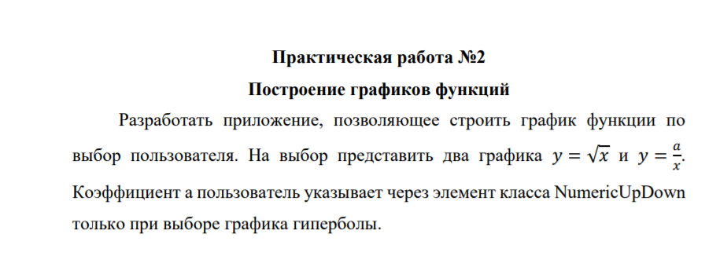

Graphics g;

public Form1()

{

InitializeComponent();

}

private void button1_Click(object sender, EventArgs e)

{

pictureBox1.Image = new Bitmap(pictureBox1.Width, pictureBox1.Height);

g = Graphics.FromImage(pictureBox1.Image);

SolidBrush sb = new SolidBrush(Color.Black);

Point p1 = new Point(0, 200);

Point p2 = new Point(400, 200);

Pen w = new Pen(Color.Red);

g.DrawLine(w, p1, p2);

Point p3 = new Point(200, 0);

Point p4 = new Point(200, 400);

g.DrawLine(w, p3, p4);

for (int i = 0; i <= 180; i++)

{

g.DrawEllipse(w, 200 + i, 199 - Convert.ToInt32(Math.Sqrt(i)), 2, 2);

}

}

private void Form1_Load(object sender, EventArgs e)

{

numericUpDown3.Value = 100;

}

private void button2_Click(object sender, EventArgs e)

{

pictureBox1.Image = new Bitmap(pictureBox1.Width, pictureBox1.Height);

g = Graphics.FromImage(pictureBox1.Image);

SolidBrush sb = new SolidBrush(Color.Black);

Point p1 = new Point(0, 200);

Point p2 = new Point(400, 200);

Pen w = new Pen(Color.Red);

g.DrawLine(w, p1, p2);

Point p3 = new Point(200, 0);

Point p4 = new Point(200, 400);

g.DrawLine(w, p3, p4);

int k = Convert.ToInt32(numericUpDown3.Value);

for (int i = 1; i <= 180; i++)

{

g.DrawEllipse(w, 210 + i, 190-(k/i), 2, 2);

g.DrawEllipse(w, 210 + (k / i), 190 - i, 2, 2);

g.DrawEllipse(w, 190 - (k / i), 210 + i, 2, 2);

g.DrawEllipse(w, 190 - i, 210 + (k / i), 2, 2);

}

